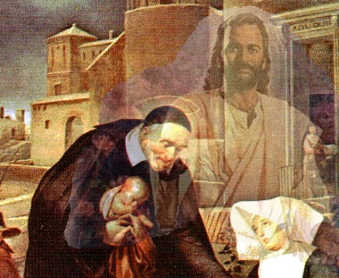
Saint Faustina Conference
Guidelines

- We adhere to the Society’s The Rule and The Manual.

- Our role in serving our Lord is to listen, discern and decide the best way to love those who come to us. (physically or telephonically)

- We seek out and find the poor, the needy and the forgotten within the Saint Matthew and Saint Patrick Parishes.

- We make every effort possible to provide for those who are in need of help.

- Help comes in many forms: spiritual, listening, friendship, knowledge, love, encouragement, inspiration, and material.

- We seek to help families make systemic changes in their lives.

- We protect children at all times and in any circumstance.

- We love one another as the Lord has loved us.

- We come together as a family of Christian brothers and sisters.

- We always provide time, volunteers, and resources to other Conference ministries and special activities/events. We help one another! See the Conference’s three Organization Charts.

- We keep Faith with the Lord that He will show us daily, His way to help the poor, the needy, and the forgotten. See the Conference’s Prayer, “At Day’s End”

“All things are possible through the Lord”

