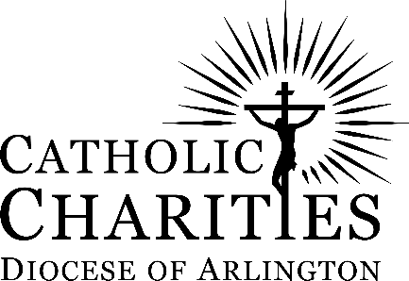
Emergency Assistance Guidelines:
Financial Support for Rent or Utility

Leesburg Regional Office: 316 E. Market Street, Leesburg, VA 20176, Telephone: 703-443-2481
Loaves and Fishes Food Pantry: 613 N. Royal Avenue, Front Royal, VA 22630, Telephone: 540-252-4320
Christ House: 131 S. West Street, Alexandria, VA 22314,
Telephone: 703-548-4227 (press option 5)

Catholic Charities emergency assistance program aids people experiencing a one-time financial crisis in their lives. We help in preventing evictions or the termination of essential utilities and our primary goal is to help people remain in their homes or to keep their utility turned on. We serve residents of the Diocese of Arlington regardless of their race, creed, religion or national origin. The demand for our services is very high and we have limited funds, so assistance is given on a first-come, first-serve basis.
Eligibility
Eligible clients may receive Emergency Assistance once in a 12-month period, up to 2 times in a 10-year period. No walk-ins are accepted. An interview appointment must be made by telephone. Screening for eligibility occurs at the time of the call with a description of the crisis.
Christ House serves: Arlington County, City of Alexandria, City of Falls Church, City of Fredericksburg, City of Manassas, City of Manassas Park, Fairfax County (except Herndon, Reston), Orange County, Prince William County, Spotsylvania County, Stafford County, King George County, Lancaster County, Northumberland County, Richmond County and Westmoreland County. Leesburg Regional Office serves: City of Winchester, Clarke County, Culpeper, Herndon, Reston – Fairfax County, Fauquier County, Frederick County, Loudoun County, Madison County, Page County, Rappahannock County, Shenandoah County and Warren County. Please call the office that serves your community.
At the interview a current hard copy of all required documents including a current photo ID must be presented. No digital copies of documents are accepted. Re-application for assistance is required if all documents are not provided at time of interview and funds cannot be held. Prior to the interview you are responsible for paying the amount owed above the amount Catholic Charities can pledge (the amount is discussed during the telephone screening). Whenever possible, Catholic Charities provides referrals to locate additional funds. Proof of those payments must be brought to the interview. Catholic Charities is always the last payer on the bill.
We regret that we cannot help if you are living in Section 8 Housing, public housing or subsidized housing of any type because you are already receiving financial benefit/assistance for your housing. Financial Assistance is not provided to anyone living at the same address as the landlord or sub-leasing. We do not assist with mortgage payments.
Requirements for all: The family must have a verified source of income and at least one proof of income from the list below:

Recent pay stubs and/or 1099 Court-ordered child support Unemployment Compensation
Disability TANF (Temporary Assistance Social Security and/or SSI
Worker’s Compensation Needy Families) Pension

A current hard copy of all documents required at interview. No digital copies accepted.

Requesting Rental Assistance for Non-Subsidized Housing
- Up-to-date Lease Agreement – In your name. When there is more than one leaseholder(s) all leaseholder(s) must be present at the interview or have the required forms already signed by the other leaseholder(s) at the time of the interview. If a leaseholder cannot be present at the time of the interview, the form with a copy of their photo ID must be provided by the leaseholder(s) attending the interview.
- Late (5-day Pay or Quit) or Eviction Notice – In your name.
- Current IRS W-9 form (completed by landlord/property manager and the date of the signature cannot be older than one year).
- Assistance is not provided to anyone who is sub-leasing, renting a room or basement, or is living at the same address as the landlord or renting from a family member.

Requesting Utility Assistance (Only Electric, Gas, Water & Propane are considered):
- Up-to-date Lease Agreement or Mortgage Statement for Non-Subsidized Housing – In your name.
- Past Due Bill with Disconnect/Termination Notice – In your name. When there is more than one person’s name on the bill they must attend the interview or sign the required forms and provide a copy of their photo ID.
- Assistance is not provided to anyone who is sub-leasing, renting a room or basement, or is living at the same address as the landlord or renting from a family member.

I have read and understand these guidelines.

Date __________ Client Signature _________________________________

